Lab-2
Task 5: Manage Docker Containers and Images
- Listing Docker Images:
- Building the Docker Image:
The Docker image for the application was built using the following command:
- Running and Listing Docker Containers:
The Docker containers were started using Docker Compose.
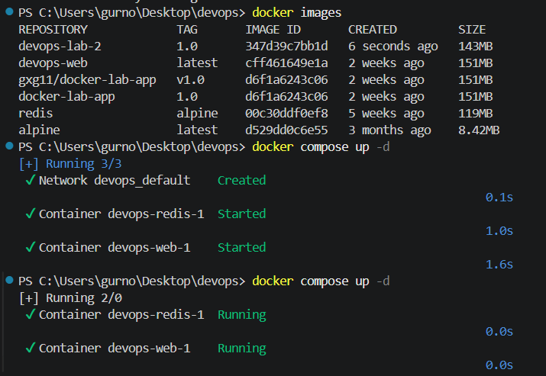
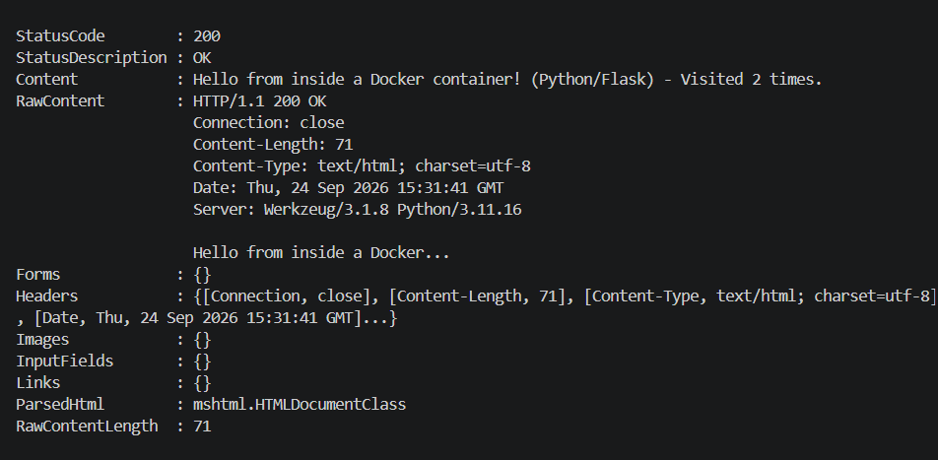
Result: The Flask web application and Redis containers were successfully started and verified using docker ps.

- Starting, Stopping and Removing Containers:
- Docker Compose Multi-Container Application:
Docker Compose was used to run the multi-container application consisting of a Flask web application and a Redis service.
- Tagging the Docker Image:
- Pushing the Image to Docker Hub.
Result: The Docker image was successfully pushed to the Docker Hub container registry. 